**High Side vs Low Side Switching**

A common task for a transistor is switching a device on and off. There are two configurations for a transistor switch: low side and high side. The choice between these two methods often depends on factors such as the specific application, component availability, and design constraints.

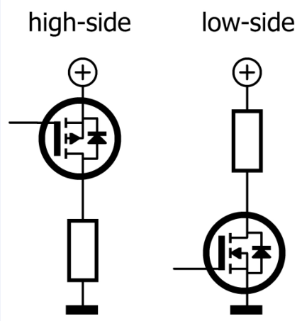

* *High side switching:*

The switch is placed between the positive supply voltage and the load, and the ground connection is directly connected to the load. Typically used in H-bridge circuits, motor control, and power supplies.

* *When to use high side switching:*

*Safety and Isolation: If it is crucial to disconnect the load from the supply for safety or power conservation.*

*Positive Voltage Control: When the application requires controlling the connection to the positive supply voltage.*

*Fault Protection: High side switching is preferable in situations where ground faults are a concern.*

* *Low Side Switching:*

The switch is placed between the load and ground and the positive supply voltage is directly connected to the load. Typically used in Solenoid valves, LED drivers, and general-purpose switching.

* *When to use low side switching:*

*Simplicity:* If the circuit design is straightforward and does not require complex gate drive circuitry.

*Cost Efficiency:* When budget constraints favor less expensive components.

*Common Ground Reference:* In systems where all components share a common ground, making it easier to control the load with ground-referenced logic.